Procedures and Functions

Q1: Create a stored procedure called uspcountriesasia to list out all the countries with continentid equal to 1, in alphabetical order

Ans: CREATE or alter PROCEDURE usp_CountriesAsia

-- Add the parameters for the stored procedure here

AS

BEGIN

-- SET NOCOUNT ON added to prevent extra result sets from

-- interfering with SELECT statements.

SET NOCOUNT ON;

-- Insert statements for procedure here

select CountryName from tblcountry where continentId=1 order by countryname asc ;

END

exec [dbo].[usp_CountriesAsia ];

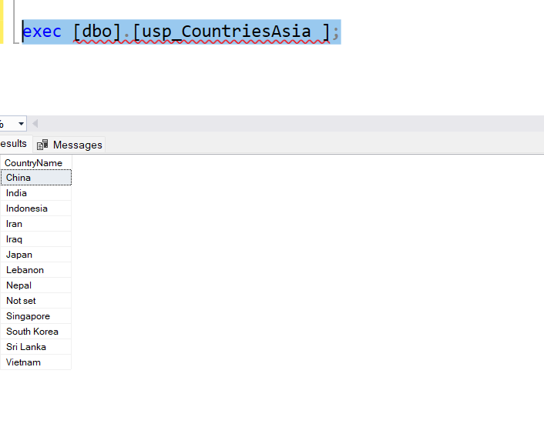

Q2:Modify the text of your query to create a different procedure called uspcountrieseurope which lists all the countries in continent id number 3

Ans: CREATE or alter PROCEDURE usp_countries_europe

-- Add the parameters for the stored procedure here

AS

BEGIN

-- SET NOCOUNT ON added to prevent extra result sets from

-- interfering with SELECT statements.

SET NOCOUNT ON;

-- Insert statements for procedure here

SELECT CountryName from tblcountry where continentId=3

END

GO

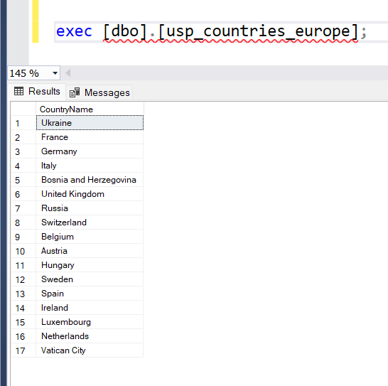

Q3: change the procedure in Q2 so that it list out the countryid also

Ans: CREATE or alter PROCEDURE usp_countries_europe

-- Add the parameters for the stored procedure here

AS

BEGIN

-- SET NOCOUNT ON added to prevent extra result sets from

-- interfering with SELECT statements.

SET NOCOUNT ON;

-- Insert statements for procedure here

SELECT CountryName,countryid from tblcountry where continentId=3

END

GO

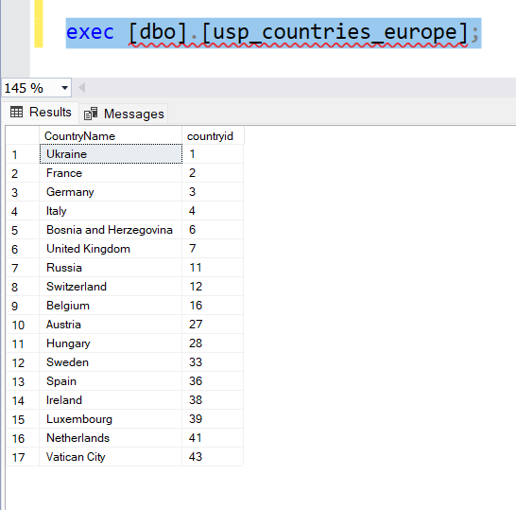

Q4:create a function for Q1

Ans: CREATE or alter FUNCTION udf_countriesasia

(

)

RETURNS TABLE

AS

RETURN

(

-- Add the SELECT statement with parameter references here

SELECT CountryName from tblcountry where continentId=1

)

GO

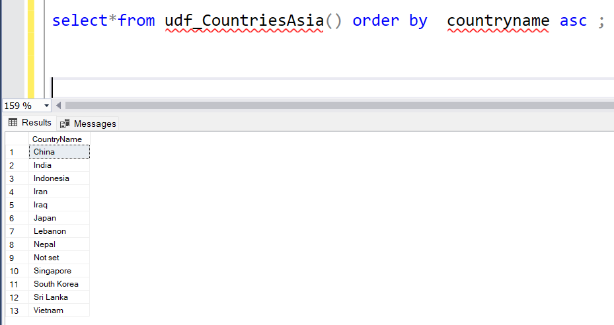

Q5:Convert Q2 into a function

CREATE or alter function udf_countries_europe()

-- Add the parameters for the stored procedure here

returns table

as

return

(

-- Insert statements for procedure here

SELECT CountryName,countryid from tblcountry where continentId=3

)

GO

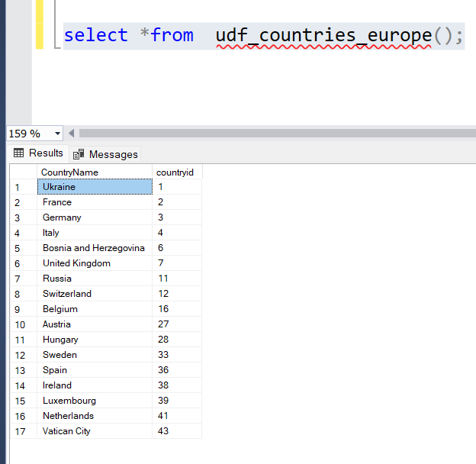

Q6: call Q3 from inside a procedure and display the results from the function

Ans: